1. Write a shell script iaop to perform integer arithmetic on two numbers, where the value of the two numbers will be given during runtime.
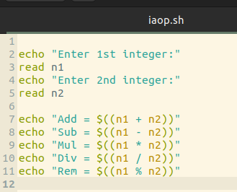

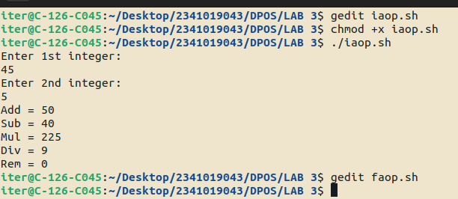
2. Write a shell script faop to perform floating point arithmetic on two numbers, where the value of the two numbers will be given during runtime.
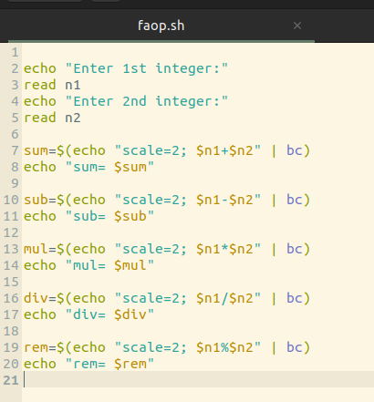

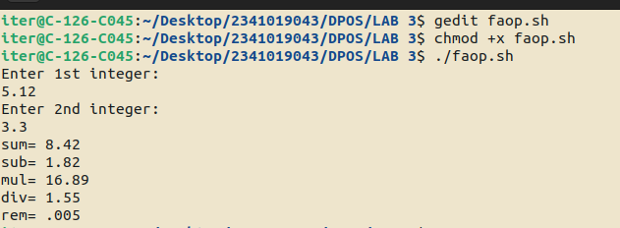

3. Ramesh’s basic salary is input through the keyboard. His dearness allowance is 40% of basic salary, and house rent allowance is 30% of basic salary. Write a program to calculate his gross salary.

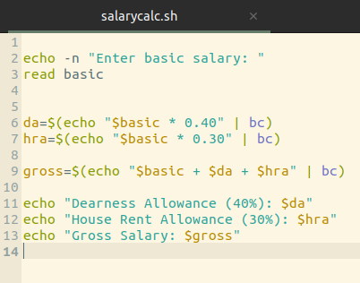

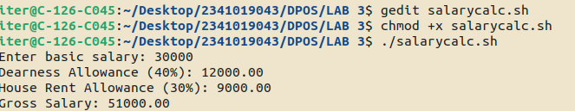

5. If cost price and selling price of an item is input through the keyboard, write a program to determine whether the seller has made profit or incurred loss. Also determine how much profit was made or loss incurred.

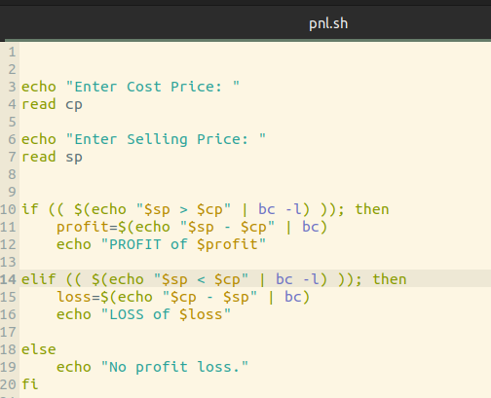

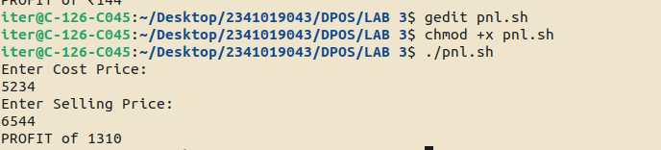

6. Write a shell script which receives any year from the keyboard and determines, whether the year is a leap year or not. If no argument is supplied the current year should be assumed.

